

**IGAD CENTER FOR PASTORAL AREAS AND LIVESTOCK DEVELOPMENT (ICPALD)**

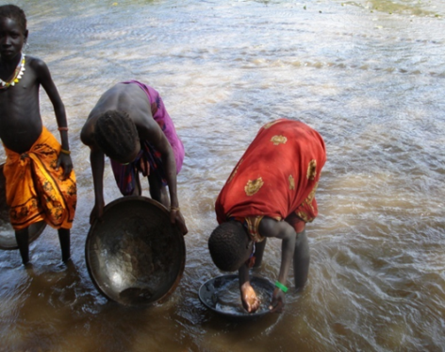

The IGAD region covers over 5.2 million Sq. Km, of which some 80% is classified as arid and semi-arid areas (ASALs), with annual rainfall of 400 mm or below. The Region has a population of over 250 million people and foreseen to increase at an average rate of 2.6%. Thus, existing natural and livestock resources are faced with challenges of overexploitation as increasing needs of population growth, urbanization and development trends rise. The region is also faced with frequent climate variability and conflicts that lead to extreme food insecurity and deterioration of livelihoods of ASAL communities. It is noted that the region is habitant to 3% of the world’s population and recipient of 40% of relief food aid. This necessitated the establishment of IGAD Centre for Pastoral Areas and Livestock Development (ICPALD), a people centred institution; to address the needs of dryland communities.

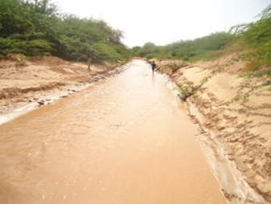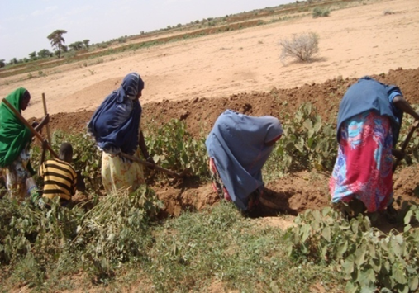In its two years of existence, the centre has identified and benchmarked priority areas of interventions on alternative livelihoods for ASAL communities; development strategies, service provision endeavours and policy areas through evidence based research on the areas of Non-Wood Forest Products and Artisanal Minerals (NWFP&AM), animal health and marketing, climate change adaptation, disaster risk management and wild-life, eco and cultural tourism in ASAL areas of IGAD region.

It is evident that Livestock sector has consistently provided more than 60% of the estimated value addition to agricultural sector, and is a substantially more important contributor to regional GDP than crop farming. NWFPs and AM are much more economically important than opportunistic farming done by pastoralists during seasonal rainfalls. Ongoing activities of surveillance of trans-boundary animal diseases, setting of sanitary and phyto-sanitary standards, building trade partnership with Middle East and North African net-importers of meat and exploring export opportunities within the African continent maximises net benefits of existing livestock potentials.

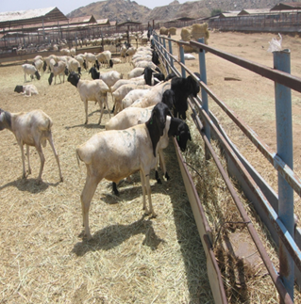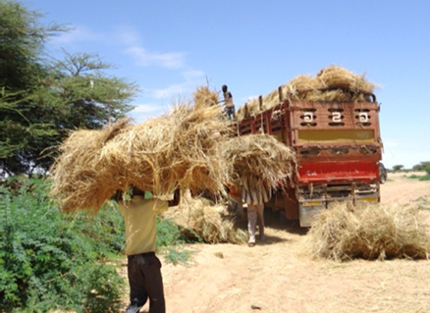

ICPALD’s mandate is to harmonize and domesticate climate change adaptation best practices in the Region in collaboration with IGAD Climate Prediction and Application centre (ICPAC) and other national and regional partners to reduce the vulnerability of ASAL communities.

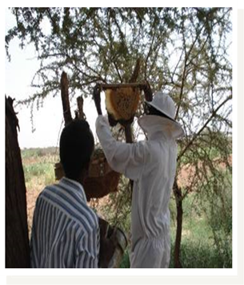The trajectories of dealing with Disaster Risks have suffered from lack of focus and appropriate development decision. Disaster impacts have persistent, long-term negative effects on development in general. Inappropriate development choices can also exacerbate vulnerabilities and aggravate the negative effects of disasters. Thus, ICPALD aims to addresses Disaster risk reduction by addressing the underlying risk factors in order to reduce avoidable loss of life, property and livelihoods. Establishment of wildlife conservancies, eco-tourism and cultural tourism in ASALs raises awareness of communities on the importance of building climate smart source of livelihood, prevents desertification using livestock and wildlife to mimic nature, conserve dryland ecosystems and environment capable of storing carbon.

ICPALD’s long term goal is to spearhead swift and appropriate development endeavours in partnership with member states, national and regional development stakeholders to dryland communities of the IGAD region.

