**Introduction to IGAD Center for Pastoral Area and Livestock Development (ICPALD)**

**By Dr. Solomon Munyua (June 2013)**

**Background of the the establishment of ICPALD**

* In 2009, IGAD Members of Parliamentarians support the establishment of Livestock Development Centre:

(a) A drylands training centre; and

(b) A livestock Centre

* In December 2009, IGAD Council of Ministers assigned IGAD Secretariat to explore the viability of establishing an institution in the Horn of Africa.
* In December 2010, Ministers for Agriculture/Livestock mandated IGAD to establish an institution responsible for Regional Livestock Development (Livestock Unit):

*(Article 5; Institutional provisions of the IGAD Animal Health Policy Framework in the context of trade and vulnerability of the member states)*

* 2011 IGAD Executive Secretary (ES) appointed a committee of regional experts. The committee recommended viability of a “dry-land and livestock centre” (ICPALD established),
* 2011 – STVS protocol signed
* In July 2012, the 45th IGAD Council of Ministers mandated IGAD secretariat to establish *“IGAD Centre For Pastoral Areas and Livestock Development (*ICPALD)*”*

**Role of ICPALD**

* Technical arm of the IGAD secretariat for the livestock sector,
* Convening technical expertise within the region and facilitating decision making to the highest level of governments,
* Provide technical support to MS in livestock policy processes,
* Coordinate with relevant regional technical institutions in the field of livestock (AUIBAR, FAO, the OIE and Codex),
* Undertake studies on approaches, strategies and capacities that attains international standards and recommend steps to achieve MS’s compliance,

**ICPALD Strategy & protocol**

* Inclusive ICPALD strategy (2013-2017) in the process and to be validated inclusively (**Currently ongoing process**),

**ICPALD Mandate, Vision, mission and overall objective**

* The Mandate of the Centre would therefore be to: “Promote and facilitate sustainable and equitable drylands and livestock development in the IGAD region”
* The vision of the Centre is to: “Be the premier centre of excellence for promoting drylands and livestock development”
* The Mission of the Centre is to: “Compliment efforts of IGAD member states to sustainably generate wealth and act as regional policy institution for livestock and drylands”
* The overall objective of the Centre will be to: “Promote and facilitate Regional Policy framework and advocate for people centered and gender responsive sustainable development of drylands and livestock in the IGAD region”

**To achieve the stated objective of the Centre the strategic objectives of the Centre include:-**

* Promote and facilitate the elaboration and harmonization of policies and development initiatives in livestock and drylands development in member states at regional level to integrate the region with the international standards.
* Facilitate appropriate and applicable research and technology development, including domestication, adoption and transfer, in drylands and livestock development,
* Act as an interface between the extension, research, policymaking and execution through developing Regional policies frameworks and networking with like-minded institutions at regional and international level to coordinate implementation
* Establish linkages with relevant IGAD especially ICPAC and CEWARN, and member state institutions and create synergy with international, continental and regional institutions’ programs and projects on issues pertaining to drylands and livestock development.
* Promote and facilitate need driven capacity building including training of all actors in drylands and livestock sectors in member states through organize conferences, seminars and workshops on key developmental issues related to livestock and dryland.

**To realize the stated objectives the following core functions are proposed:-**

* Undertake situational analysis including policy review and support the analysis and harmonization of regional/national policy in standard issues, legal, regulatory and institutional frameworks relating to drylands and livestock development in member states,
* Collaborate with ICPAC, in downscaling climate prediction products, and CEWARN, in the application of conflict early warning in drylands and livestock development,
* Promote and facilitate knowledge management services including information sharing and documentation, on issues relevant to its mandate,
* Support member states to create an enabling environment for Public-Private Partnerships (PPPs) in drylands and livestock development and marketing,
* Establish linkages with relevant member state institutions and create synergy with international, continental and regional institutions’ programs and projects on issues pertaining to drylands and livestock development,
* Support and facilitate the establishment of linkages between producers, Extension, marketing, research, policy making and execution while promoting extension and research and use of appropriate technology for drylands and livestock development,
* Support and facilitate capacity building of all actors in drylands and livestock development,
* Support diversification of livelihoods, employment and wealth generation options including fisheries, non-wood forest products among others.
* Provide consultancy and advisory services to member states regarding livestock and drylands including bio and eco-enterprises,

**ICPALD Vision and Mission**

* Vision: Be the premier center of excellence for promoting dry lands and livestock development policies in the IGAD member states,
* Mission: Compliment efforts of IGAD member states to sustainably generate wealth, employment and act as regional policy reference institution for livestock and dry lands

**Strategic objectives**

* Promote and facilitate elaboration and harmonization of regional livestock and dry-lands policies and development initiatives of MS,
* Facilitate and support the domestication, adoption and transfer of appropriate research and technology in dry-lands and livestock development,
* Act as an interface between the extension, research, policymaking and execution and coordinate implementation,
* Establish linkages with other IGAD specialized institutions especially ICPAC, ISSP and CEWARN, and member state institutions and create synergy with international, continental and regional institutions’ programs and projects on issues pertaining to dry lands and livestock development.
* Promote and facilitate need driven capacity building of MS,

**Core functions of ICAPLD**

* Review, analyze and harmonize dry lands and livestock development policies,
* Collaborate with ICPAC and CEWARN in downscaling climate prediction products and on conflict early warning in dry lands and livestock development,
* Promote and facilitate knowledge management, information sharing and documentation
* Support MS to create an enabling environment for PPPs in dry-lands and livestock development and marketing,
* Establish linkages with relevant MS, regional, international and continental institutions on drylands and livestock development,
* Support and facilitate the establishment of linkages between producers, Extension, marketing, research, technology, policy making and execution,
* Support and facilitate capacity building,
* Support diversification of livelihoods, employment and wealth generation options,
* Provide consultancy and advisory services to member states,

**Ongoing projects/programs/activities**

* Linking climate prediction products to end users,
* Facilitating and supporting livestock value chain actors,
* Alternative livestock and meat market
* Expanding sources of wealth and employment creation,
* Supporting regional training institutions and networks,
* Support internship program,
  + Short-term internship (4 -12 months),
  + Post graduate trainings (PhD, MSc, Internships) in selected areas.
* ICPALD is also working on resource mobilization to support regional programs,
* ICPALD contributions to the development of IDDRSI and one of the implementer of the new initiative,

**Photo Gallery on Ongoing projects/programs/activities**

1. Promoting market access: Sheep from the IGAD region in the Gulf market

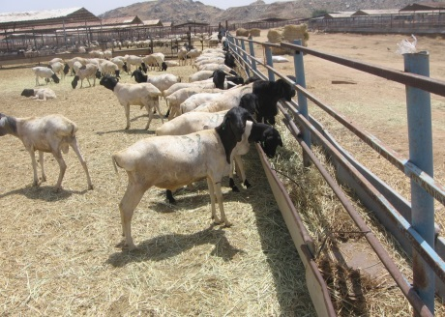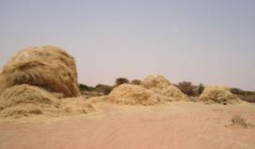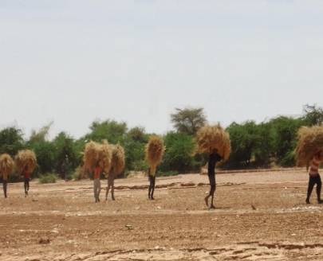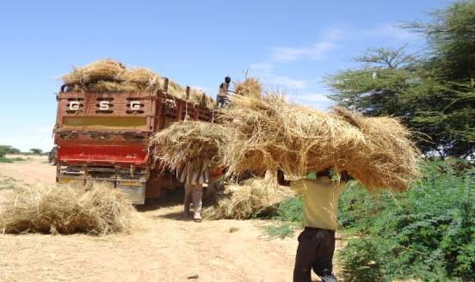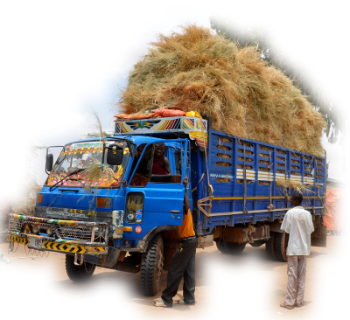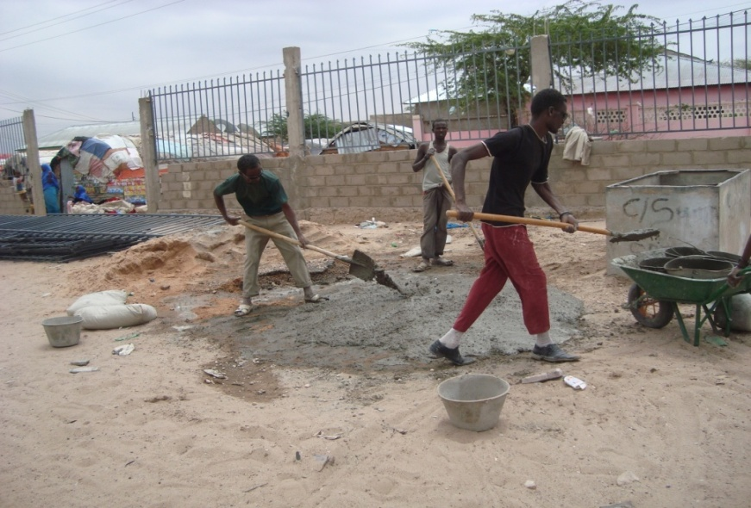

1. Promoting and facilitating conflict, gender and environment sensitive and responsive Dry land products - Value addition in areas of production (Gum Arabic, resins and spices, artisanal minerals and honey

[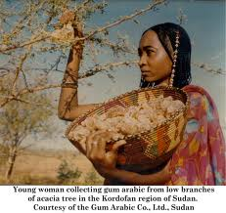](http://www.google.co.ke/imgres?imgurl=http://sparror.cubecinema.com/cola/cola_ingredients/gum_arabic_woman.jpg&imgrefurl=http://sparror.cubecinema.com/cola/cola_ingredients/&h=1268&w=1346&sz=156&tbnid=sRvM478fCoLJZM:&tbnh=92&tbnw=98&zoom=1&usg=__YtBJZkpBY32n5Ym9Cl2_KAj36Yg=&docid=pALxS5TFxGcE6M&hl=en&sa=X&ei=sh0yUc-QCYnK0QWDoIG4BQ&ved=0CEAQ9QEwBg&dur=2901)[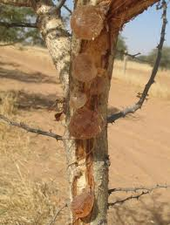](http://www.google.co.ke/imgres?imgurl=https://www5.montpellier.inra.fr/var/internet5_montpellier_ecosols/storage/htmlarea/ArabicGum.bmp&imgrefurl=https://www5.montpellier.inra.fr/ecosols/Recherche/Les-projets/AcaciaGum&h=549&w=415&sz=670&tbnid=I53pvuxQPdYapM:&tbnh=91&tbnw=69&zoom=1&usg=__JbJOxXl8U7mTECpFkcalYKukO48=&docid=RCn5MM0n0GChXM&hl=en&sa=X&ei=sh0yUc-QCYnK0QWDoIG4BQ&ved=0CFYQ9QEwDQ&dur=7410)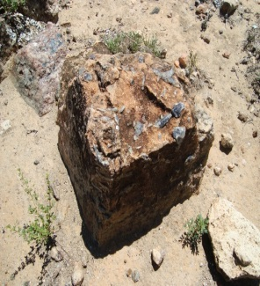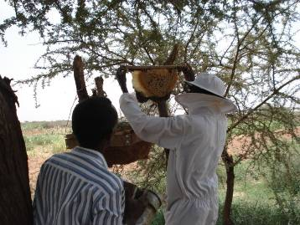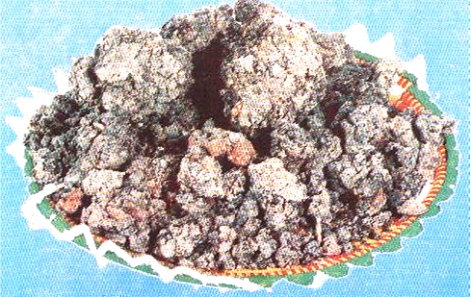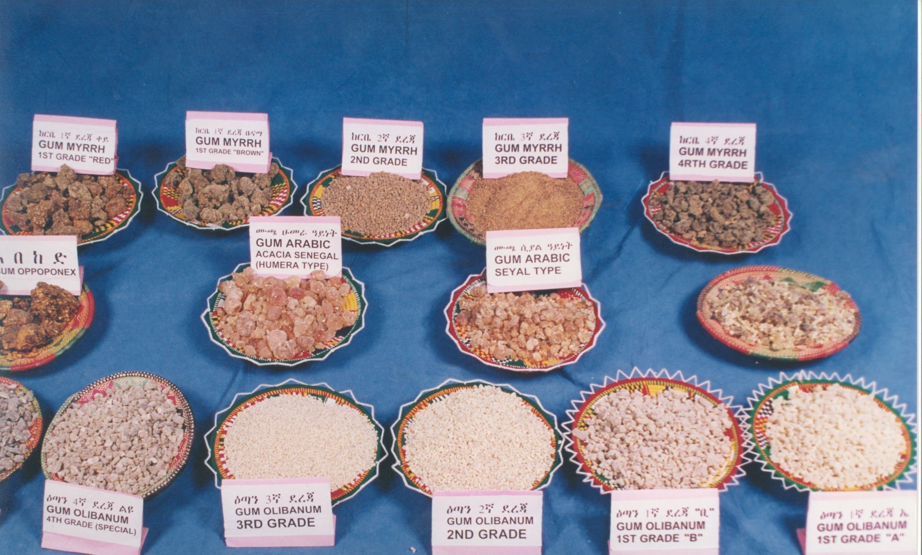

1. Promoting and facilitating sustainable, conflict, gender and environment sensitive and responsive dryland agriculture, water harvesting, storage and dryland irrigation

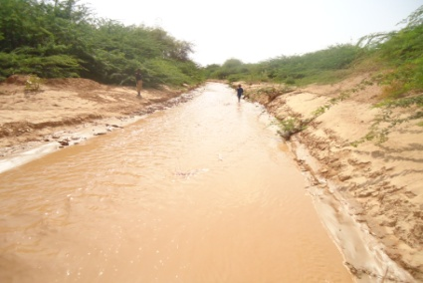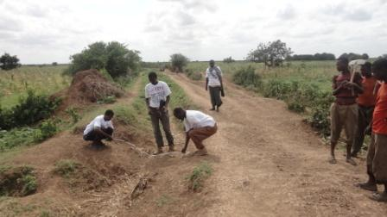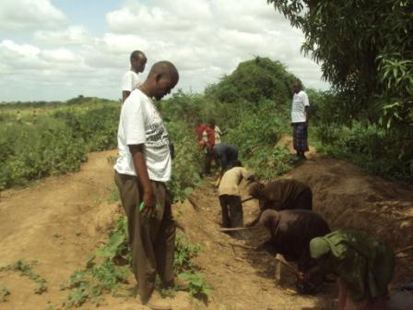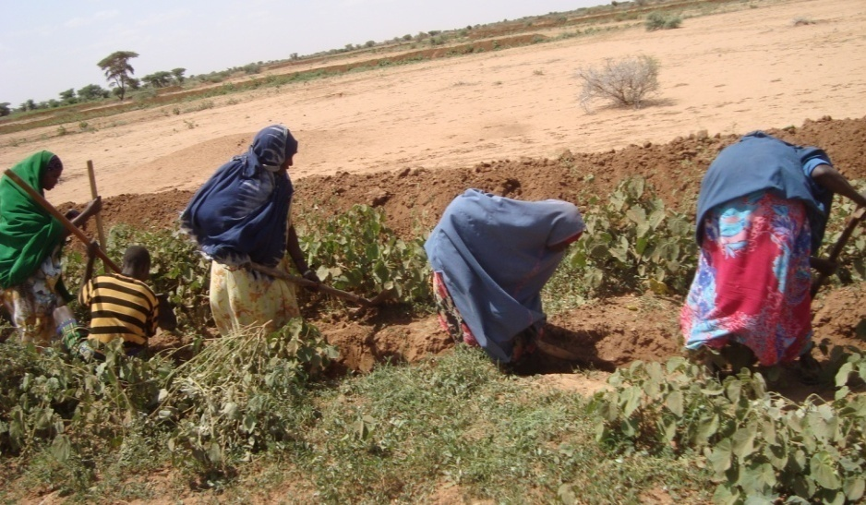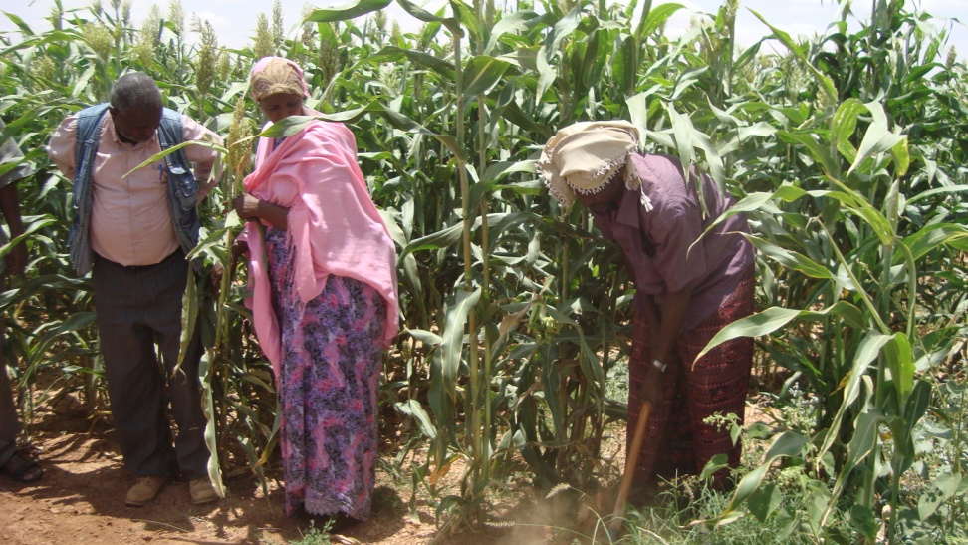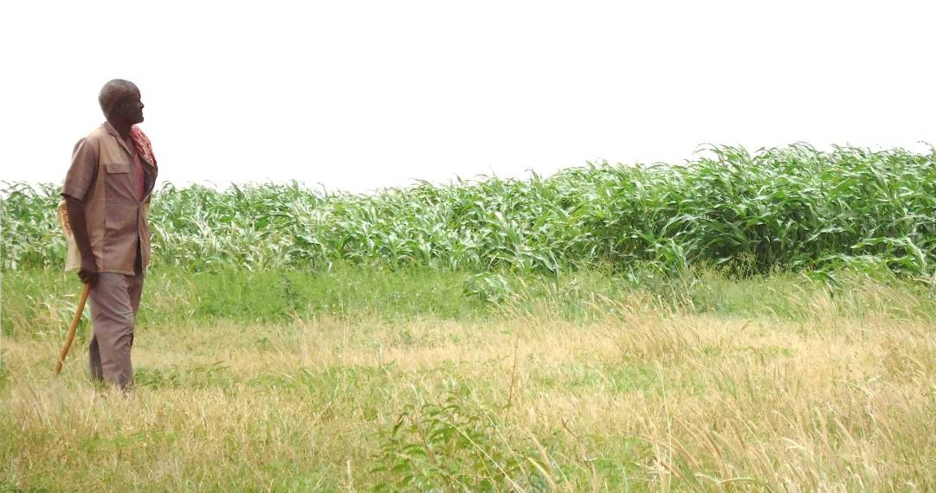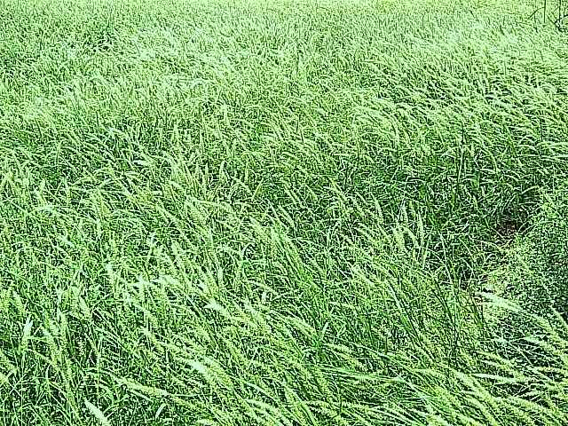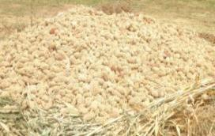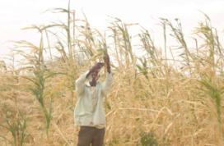

**Some suggested challenges – water harvesting and storage and dryland irrigation**

1. **Alternative crops and medicinal plants**

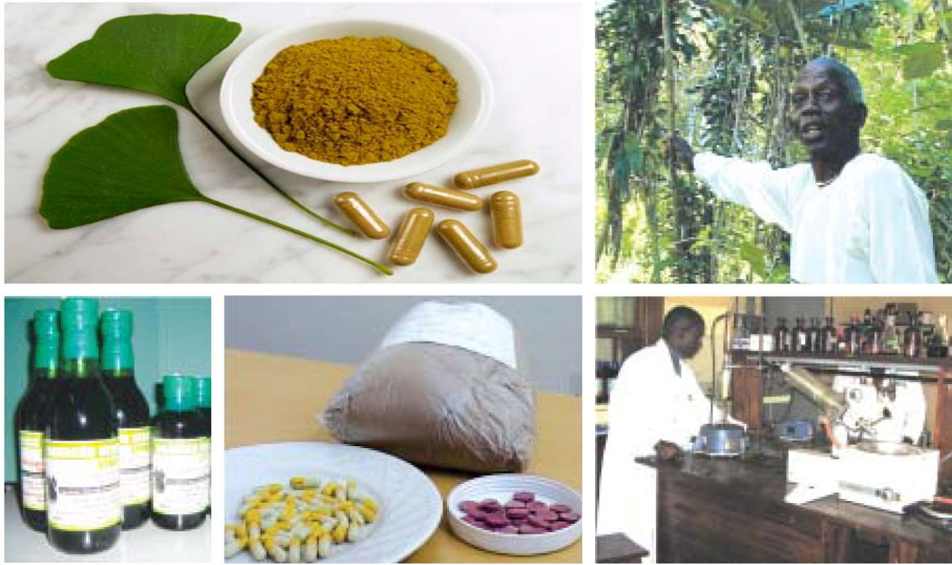

1. **Enterprise development**
2. **Chopping air dried meat**

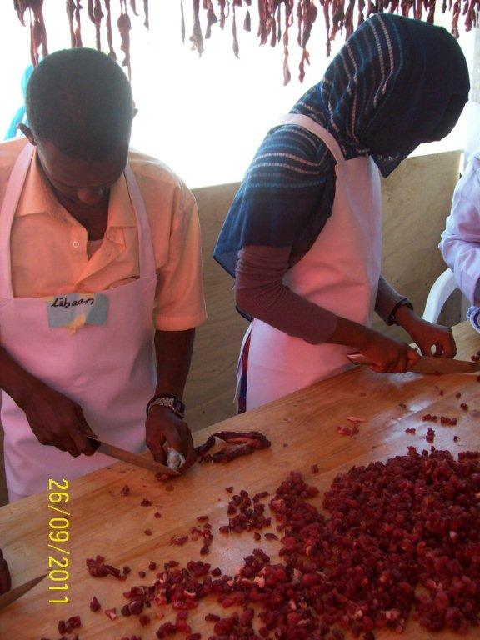

1. **Hygiene packaging of mugmad**

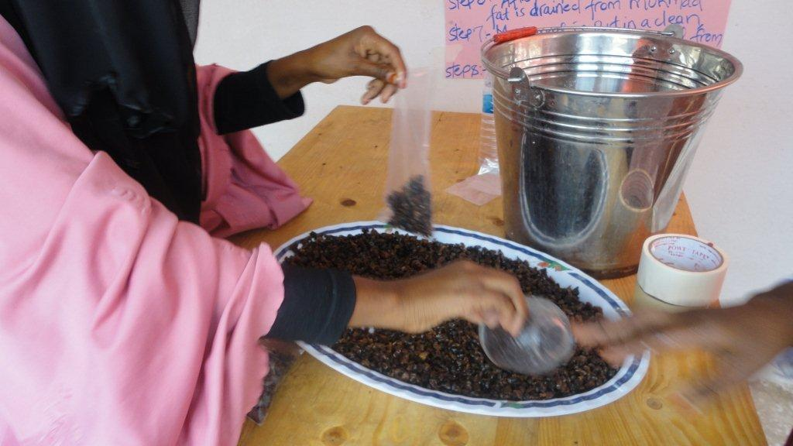

1. **Packed mugmad**

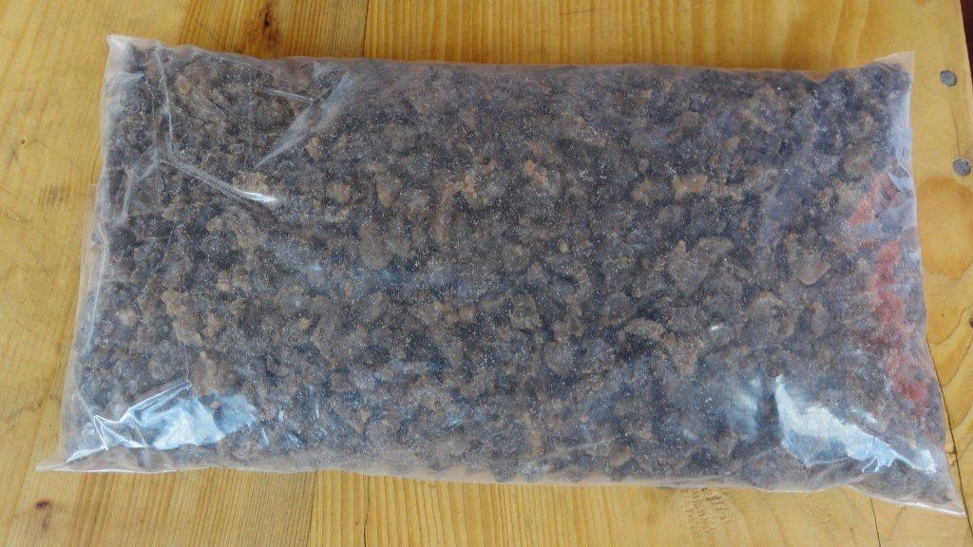

**Increased competition and price**

1. **Enterprise development Fat harvesting**

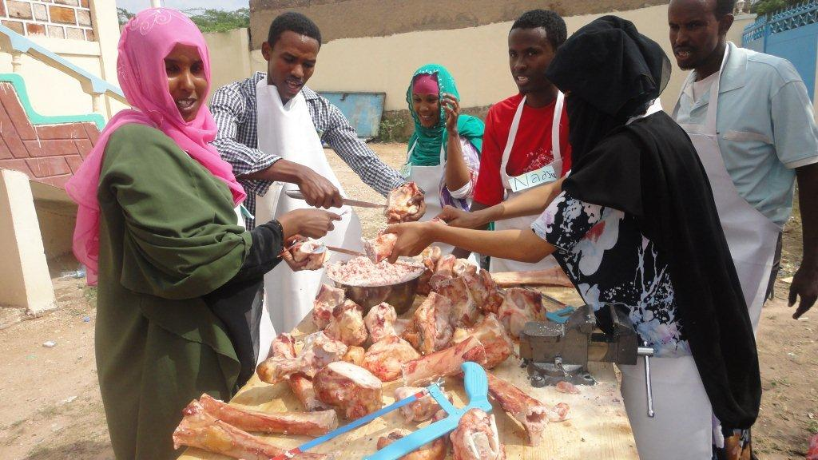

**(b) Boiling extracted fats for soap making**

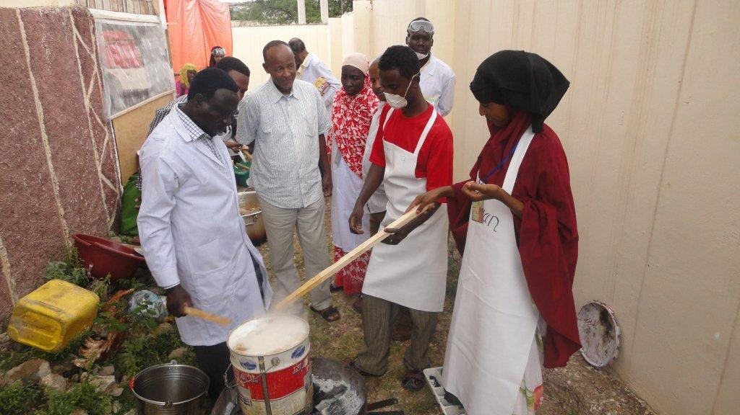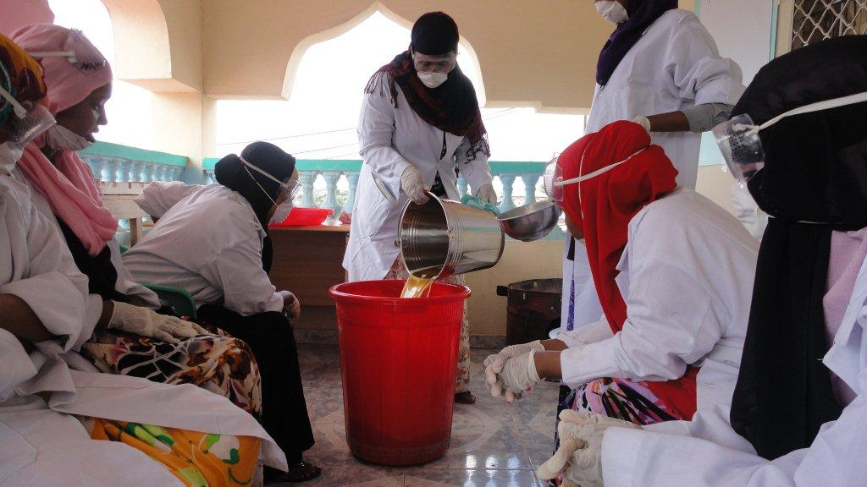

**(c ) Finished soap product**

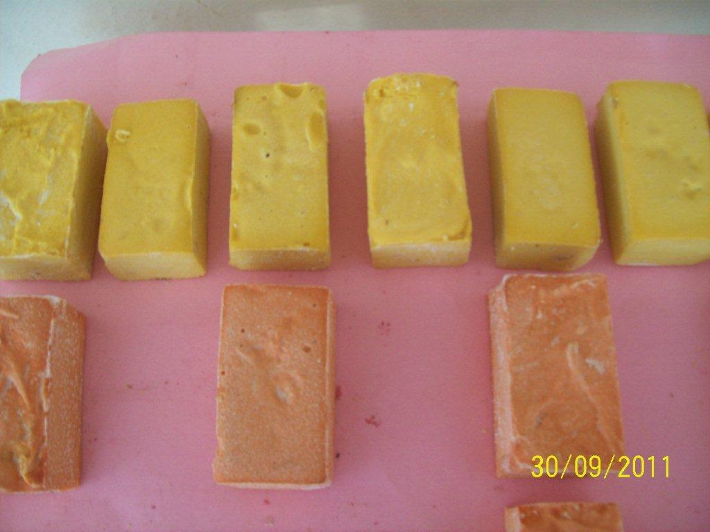

1. **Packaged soap**

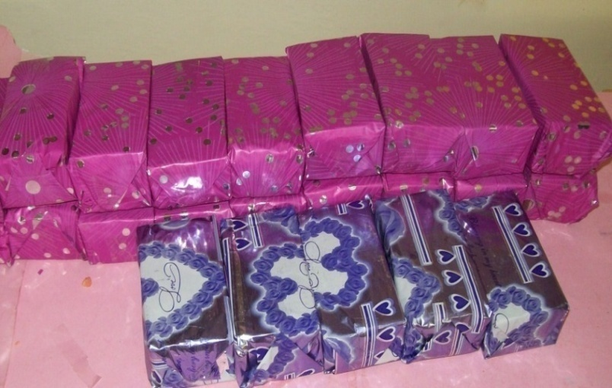

1. **Bone craft**
2. **Bone craft and fats harvesting**

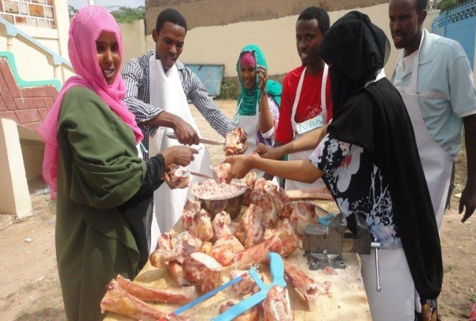

1. **Bones cleaning**

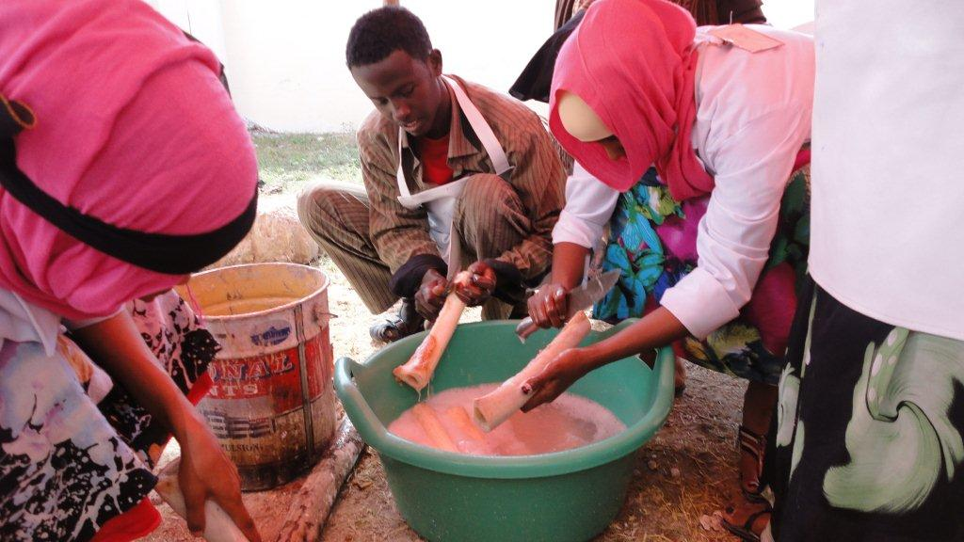

1. **Cleaned and processed bones –raw materials for product development**

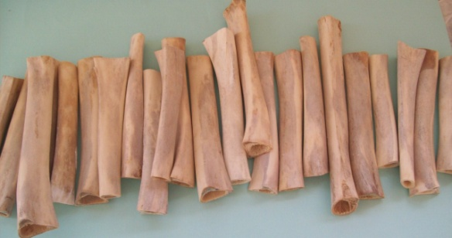

1. **Processed bones for product development**

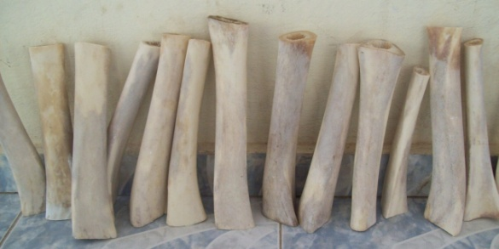

1. **Finished products**

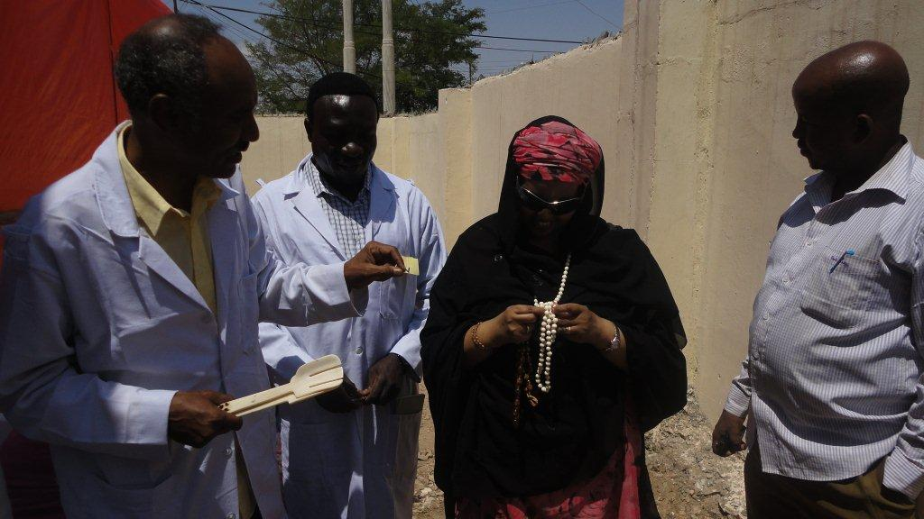

**Joint programs with AU-IBAR, FAO and JICA/Health Desk**

1. AU-IBAR – EU funded - VetGov and PASPSO
2. FAO-IGAD – FTSP – ICPAC downscaling climate products for ASALs in MS and inform community action plans
3. RISP II – Mapping of resources, ICPALD protocol and 2013 plans
4. FAO-AU-IBAR-IGAD
5. PPR control in the region
6. ICPAC-ICPALD – biomass and climate prediction for pastoral areas
7. AU-IBAR – SMP – funded by USAID – animal ID and inspection and certification
8. FAO-IGAD – FTSP – pastoralist and DRR policy development and cross border investment plans (peace dividend)
9. IGAD-JICA – ISTVS training facilities – value addition and farm implements
10. AU-IBAR – IGAD regional animal health program
11. FAO-IGAD – FTSP – Support to the ICPALD knowledge management and visibility
12. AU-IBAR – RECs EU funded Animal Resources Information System (ARIS)

**The relationship between ICPALD and IDDRSI**

***The 7 Priority Intervention Areas (PIAs) for building drought resilience:***

1. Coordination, institutional strengthening and partnerships
2. Natural resources and environment management
3. Livelihoods support and basic social services
4. Market access, trade and financial services
5. Research, knowledge management and technology transfer
6. Conflict prevention, resolution and peace building
7. Disaster risk management, preparedness and effective response

**Opportunities under IDDRSI**

1. Map resources – water, NWFPs, minerals, livestock routes, Markets and Diseases, conflict
2. Identify cross-border community level indicators to trigger national intervention
3. Develop supportive policy and legal frameworks and integrate interventions into national strategies
4. All interventions should be people centered and aimed at creating wealth and employment - resilience
5. Institutional, policy and legal frameworks to support use of cross border resources, migration and trade
6. Invest in value addition in areas of production
7. Knowledge management (better ways of cooperation & coordination between public and private sector
8. Assess surface and underground water sources - invest in water harvesting
9. Strengthen community governance and support structures
10. Invest in range management, & fodder and food production, storage and distribution