IGAD /ICPALD organized the 7th regional coordination meeting to enhance control and eradication of Peste des petits ruminantes (PPR)
June 24-25, 2019 Kenya

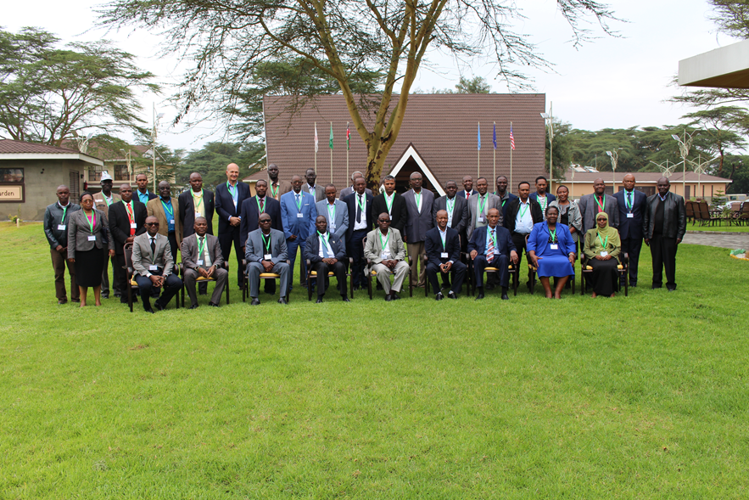

Peste des petits ruminantes (PPR) and other key small ruminant diseases (SRDs) are among those considered trade-sensitive diseases in the IGAD Region. The IGAD Centre for Pastoral Areas and Livestock Development (ICPALD), after having established the regional PPR control and eradication coordination committee (CECC), developed regional PPR strategies and programme for the control and eradication of PPR, asisted IGAD countries to develop national PPR strategies and align to the regional and global strategies. These actions are beliveved to contribute to joint and coordinated efforts towards erradicating PPR gloably by 2030. The objectives of the meeting were to review the progress and updates on regional, continetal and global PPR control and eradication programme, to recieve updates on PPR control and eradication efforts at national levels including resource mobilization efforts and to coordinate, exchange good practices and lessons on PPR/SRD Control and eradication programmes in the region. The pparticipants were Directors of Veterinary Services (CVOs) and PPR Focal Persons from ten member states of Eastern Africa, regional Laboratory, EPI and quarantine coordinators from the region and technical partner international organisations such as AU-IBAR, FAO, OIE, PANVAC, ILRI and ICPALD. The meeting conducted on June 24-25, 2029 in Naivasha, Kenya. Dr. Obadiah Njagi, the Chief Veterinary Officer (CVO), Kenya, opened the workshop. Welcome remarks were also made by Dr. Ameha Sebsibe representing Director of ICPALD, Dr. Baboucaar Jaw representing Directorof AUIBAR and Dr. Gijs VanKlooster representing FAO Ethiopia.

The key recommendations:

- Member states (MS) to focus on PPR Monitoring and Assessment tools (PMAT) and the OIE Terrestrial Animal Health Code (TAHC - Chapter 14.7) for assessment and guidance to MS on progressing from one step to the other along the PPR control and eradication pathway;
- Resource mobilization: MS to mainstream PPR control and eradication programme to appropriate livestock and resilience programmes
- Work on introduction and implementation of appropriate public private sector partnerships (PPP) in the delivery of PPR vaccination using available resources;
- MS and stakeholders / partners to undertake intensive awareness and buy-in campaigns, along small ruminant value chain for adequate national financial support to PPR control and eradication within broad rural development programmes
- Strengthen coordination at national, cross border and inter-regional economic communities level to enhance coordinated control and eradication of PPR

ICPALD expresses appreciation to the SHARE Ethiopia project /FAO Ethiopia /and AUIBAR /EU/ for funding this activity

