Seasonal Rangeland Forage Prediction (October-December 2026)
The cross-border forage prediction model is an important planning and decision support tool aimed at informing the livestock and other relevant sectors on the seasonal outlooks on forage condition. It is also intended to form the basis for tailored advisories for anticipatory action. It covers the Ethiopia, Kenya, Somalia, South Sudan, and Uganda borderland areas.
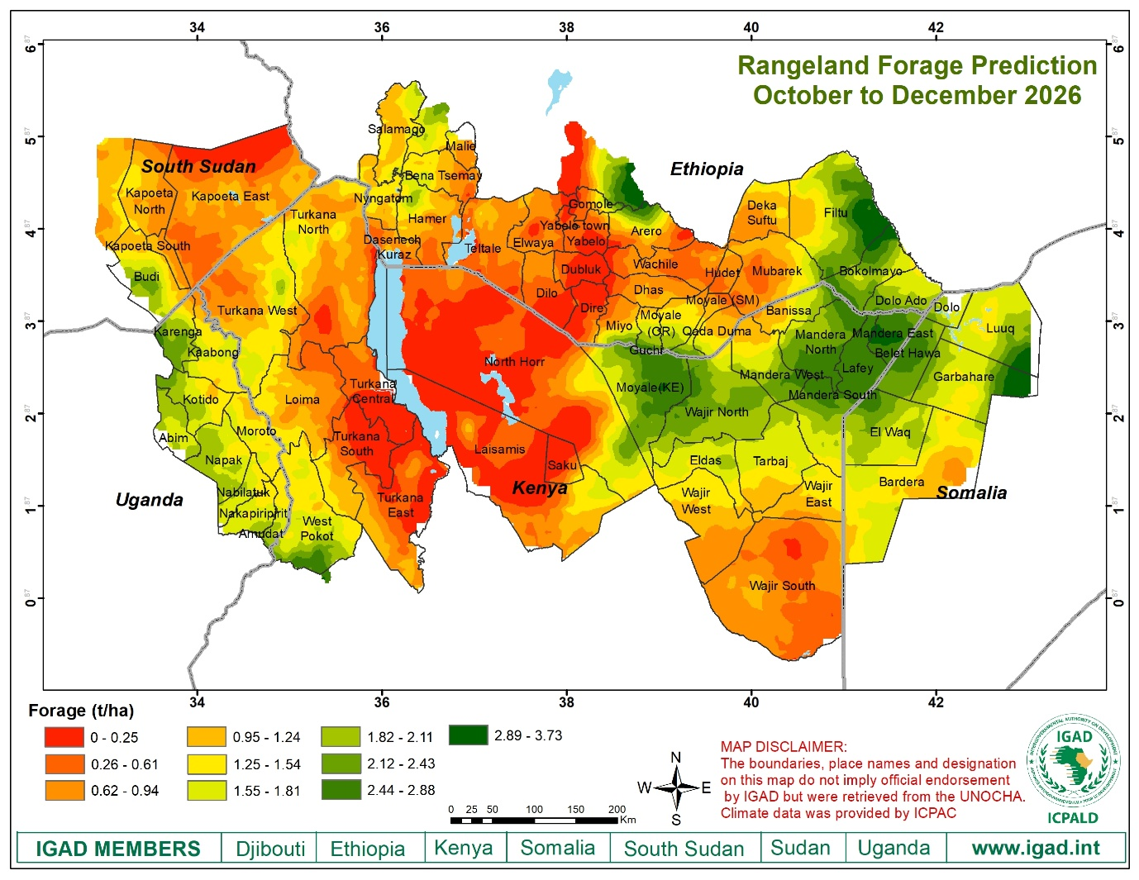

The outlook
Regeneration and better pasture conditions are expected in the cross-border areas, especially along northeastern Uganda (Kaabong, Karenga, Kotido, Napak, Abim, Amudat, Nabilatuk, and Nakapiripirit districts); Somalia (Belet Xawa, Garbahare, Luuq, Dolo and Elwaq); Kenya (Southern part of West Pokot, some parts of Turkana West and Turkana North, Moyale, Wajir North, Mandera West, Mandera South, Mandera North, Mandera East, Mandera South, and Lafey); Southern Ethiopia (Southern Miyo, Guchi, Moyale, northern Arero, northern Hamer, Bokolmayo, Dolo Ado, and Filtu ), South Sudan (Budi); Relatively high > 2.12 t/ha).
However, relatively poor forage conditions are expected in the cross-border areas of Southern Ethiopia (Quadaduma, Hudet, Mubarak, Wachile, Dhas, Dheka suftu, Dire, Dilo, Dubluk, Yabelo, Elwaya, Teltal, Salamago, Bena Tsemay, Nyangatom, and Dasenech); Kenya Marsabit (North Horr, Laisamis, Saku), Turkana south, Turkana east, Turkana central); Somalia (Bardera); South Sudan (Kapoeta north, Kapoeta south, and Kapoeta East); Relatively low < 2.0 t/ha.

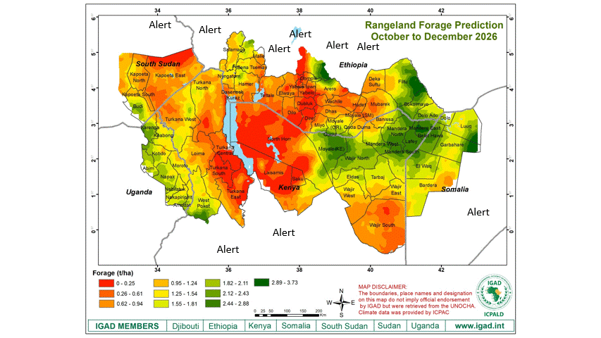

State of Livestock population along the cross-border areas of IGAD clusters (Karamoja, Moyale & Mandera)
Below is the distribution of livestock populations by animal type aggregated at sub national administrative units along the cross-border areas of IGAD clusters. The type of livestock includes cattle, goats, sheep, donkeys, and camels.
Table 1: Livestock population in the clusters of Karamoja, Moyale & Mandera
Cluster | Camels | Goats | Cattle | Sheep | Donkeys | Total
Karamoja | 1,187,948 | 20,096,910 | 12,563,403 | 15,658,332 | 931,122 | 50,437,715
Mandera | 2,633,052 | 8,327,861 | 2,411,982 | 3,785,070 | 1,349,969 | 18,507,934
Moyale | 525,078 | 7,292,339 | 1,871,911 | 6,061,055 | 330,230 | 16,080,613
Total | 4,346,078 | 35,717,110 | 16,847,296 | 25,504,457 | 2,611,321 | 85,026,262
Source: ICPALD livestock database 2025
The above table shows goats are the dominant livestock species within the cross-border areas of IGAD the clusters of Karamoja, Moyale & Mandera, followed by sheep, cattle, camels, and Donkeys. Karamoja cluster holds the largest population of livestock, followed by Mandera and Moyale.
Figure 1: Livestock population in the clusters of Karamoja, Moyale & Mandera
Table 2: Livestock population in Karamoja Cluster.
Admin unit | Cattle | Camel | Goat | Sheep | Donkey
Abim | 12,061 | - | 17,210 | 225 | -
Amudat | 690,681 | 8,476 | 1,083,977 | 424,627 | 4,388
Aroo | 470,996 | 77,776 | 974,995 | 184,880 | 4,107
Budi | 608,331 | - | 2,335,806 | 1,244,161 | 1,412
Dassenech | 1,087,440 | 1,593 | 1,160,793 | 884,151 | 18,885
Kaabong | 10,782 | - | 50,993 | 39,285 | 1,516
Kacheliba | 2,800 | 2,100 | 28,500 | 22,400 | 50
Kapoeta East | 2,834,000 | 100 | 1,885,000 | 2,888,000 | 350,000
Kapoeta North | 558,000 | - | 1,540,000 | 781,000 | 58
Kapoeta South | 880,000 | 120 | 1,600,000 | 1,200,000 | 50
Karenga | 3,610 | - | 8,669 | 2,257 | 38
Kibish | 643,220 | 224,372 | 1,091,305 | 984,318 | 93,495
Kipkomo | 47,432 | 107 | 83,102 | 55,029 | 434
Kotido | 507,985 | 15 | 400,621 | 1,232,456 | 15,000
Loima | 262,904 | 39,604 | 344,128 | 307,587 | 18,000
Lokichoggio | 329,059 | 83,345 | 534,012 | 442,611 | 39,485
Lokiriama | 613,442 | 59,407 | 516,191 | 461,380 | 42,001
Moroto | 160,000 | 1,350 | 190,000 | 82,000 | 1,380
Nabilatuk | 169,485 | - | 95,001 | 63,188 | 2,396
Nakapiripirit | 72,070 | 17 | 55,500 | 36,420 | 1,760
Napak | 136,903 | 30 | 89,683 | 109,620 | 2,682
Pokot Central | 109,600 | 500 | 400,000 | 154,328 | 679
Pokot North | 82,065 | 32,500 | 175,000 | 140,000 | 1,174
Pokot South | 84,830 | - | 17,536 | 71,452 | 434
Suguta | 92,437 | 23,677 | 250,784 | 218,055 | 24,756
Surma | 435,500 | - | 178,623 | 32,300 | 7,655
Turkana Central | 154,617 | 71,100 | 585,294 | 466,537 | 57,352
Turkana East | 309,465 | 107,861 | 839,583 | 730,013 | 67,702
Turkana North | 361,823 | 168,428 | 1,376,911 | 970,706 | 98,713
Turkana South | 52,933 | 116,664 | 649,998 | 123,254 | 4,107
Turkana West | 548,432 | 166,690 | 1,335,032 | 1,106,528 | 70,305
West Pokot | 230,500 | 2,116 | 202,663 | 199,564 | 1,108
Grand Total | 12,563,403 | 1,187,948 | 20,096,910 | 15,658,332 | 931,122

Table 3: Livestock population in Moyale cluster
Admin unit | Camel | Goat | Cattle | Sheep | Donkey
Dilo | 16,022 | 107,313 | 94,000 | 207,019 | 31,246
Dire | 9,691 | 139,601 | 64,613 | 106,291 | 6,992
Hamer | 322 | 4,568,759 | 1,039,954 | 3,640,296 | 120,558
Laisamis | 117,276 | 747,817 | 124,574 | 959,774 | 54,343
Miyo | 23,025 | 190,699 | 90,768 | 102,832 | 9,075
Moyale ETH | 28,500 | 74,830 | 41,000 | 52,548 | 10,000
Moyale KE | 77,600 | 146,523 | 67,000 | 75,748 | 17,000
North Horr | 200,542 | 615,624 | 72,752 | 460,812 | 856
Saku | 49,600 | 240,000 | 90,400 | 180,000 | 70,400
Teltele | 2,500 | 461,173 | 186,850 | 275,735 | 9,760
Grand Total | 525,078 | 7,292,339 | 1,871,911 | 6,061,055 | 330,230
Table 4: Livestock population in Mandera cluster
Admin unit | Camel | Goat | Cattle | Sheep | Donkey
Balet-hawa | 20,000 | 476,000 | 35,000 | 365,000 | 1,260
Banisa | 261,895 | 371,832 | 138,924 | 119,324 | 30,730
Bardera | 5,000 | 30,000 | 10,000 | 8,000 | 3,000
Bokolmayo | 58,971 | 322,199 | 28,769 | 231,294 | 95,019
Cherati | 46,167 | 354,414 | 12,503 | 235,350 | 7,545
Dheka suf | 99,620 | 189,152 | 112,750 | 140,650 | 40,350
Dollo oddo | 153,417 | 398,774 | 111,367 | 270,629 | 13,080
Dollow | 10,850 | 14,000 | 15,000 | 9,000 | 7,500
Dolo bay | 65,270 | 132,605 | 102,080 | 119,310 | 21,900
El-wak | 650,000 | 1,200,000 | 940,000 | 990,000 | 880,000
Filtu | 313,654 | 500,660 | 85,326 | 221,000 | 15,620
Garbaharey | 1,622 | 4,325 | 3,200 | 1,080 | 330
Hudat | 52,660 | 100,868 | 15,088 | 33,296 | 1,601
Kadaduma | 15,471 | 25,147 | 12,321 | 10,241 | 7,417
Lafey | 120,970 | 616,708 | 173,472 | 259,427 | 19,571
Luuq | 30,000 | 600,000 | 3,892 | 48,000 | 10,000
Mandera East | 47,023 | 339,260 | 96,789 | 124,236 | 31,984
Mandera North | 204,485 | 751,058 | 134,721 | 5,226 | 3,086
Mandera South | 88,000 | 703,641 | 74,510 | 192,837 | 31,866
Mandera West | 294,333 | 632,985 | 235,308 | 257,130 | 64,953
Moyale | 50,019 | 157,872 | 36,401 | 37,498 | 23,593
Mubarak | 43,625 | 406,361 | 34,561 | 106,542 | 39,564
Grand Total | 2,633,052 | 8,327,861 | 2,411,982 | 3,785,070 | 1,349,969

